Title | Data Manipulation and Analysis using the Starwars Dataset in R
Problem Statement | A streaming platform maintains movie records containing:  - MovieID  - Rating  - Genre  Perform:  1. Create a dataset with missing values.  2. Fill missing Rating values using average rating.  3. Remove rows with missing MovieID or Genre.  4. Convert Rating into integer type.  5. Normalize rating values.
Objectives | • To understand movie data preprocessing using the Pandas library.  • To create a dataset containing missing values.  • To identify and handle missing values in a dataset.  • To fill missing Rating values using the average rating.  • To remove records with missing MovieID or Genre.  • To convert the Rating column into integer data type.  • To normalize movie rating values using Min-Max normalization.  • To identify top-rated movies based on ratings.
Dataset  URL Link /  File | MovieID MovieTitle Rating Genre ViewCount Likes  MV101 The Last Horizon 8.5 Science Fiction 125000 11200  MV102 City Lights Comedy 98000 7500  MV103 Hidden Truth 7.8 Thriller 110000 8900  None Lost Kingdom 9.1 Fantasy 150000 13500  MV105 Digital Dreams 8.9 Science Fiction 175000 16000  MV106 Silent River Drama 87000 6100  MV107 Future Code 9.3 Science Fiction 210000 19800  MV108 Broken Compass 6.7 65000 4200  MV109 Midnight Journey 8.1 Adventure 132000 10400  MV110 Laugh Again 7.5 Comedy 105000 8100  MV111 Ocean Mystery 8.8 Mystery 143000 12100  MV112 Final Mission Action 190000 17400  MV113 Parallel Lives 8.4 Drama 118000 9600  MV114 Wild Trails 7.2 Adventure 99000 7200  MV115 The Great Escape 9.0 Action 205000 18800
Functions  Details | Sl. No. | Function | Package | Description of function
 | 1 | pd.DataFrame() | Pandas | Creates a DataFrame from the movie dataset stored in dictionary format.
 | 2 | isnull() | Pandas | Identifies missing values present in the movie dataset.
 | 3 | mean() | Pandas | Fills missing Rating values using the calculated average rating.
 | 4 | dropna() | Pandas | Removes rows containing missing MovieID or Genre values.
 | 5 | pd.to_numeric() | Pandas | Converts Rating values into numeric format and handles invalid entries.
 | 6 | round() | Pandas | Rounds decimal Rating values before converting them into integers.
 | 7 | astype() | Pandas | Converts the Rating column into integer data type.
 | 8 | min() | Pandas | Finds the minimum Rating value required for normalization.
 | 9 | max() | Pandas | Finds the maximum Rating value required for normalization.
 | 10 | groupby() | Pandas | Groups movie records according to Genre for genre-wise analysis.
 | 11 | sort_values() | Pandas | Sorts movies based on rating, popularity score or number of views.
 | 12 | fillna() | Pandas | Fills missing Rating values using the calculated average rating.
Steps/  Process/  Procedure/  Algorithm/  Flowchart/  Model | Step 1: Import the Pandas library and create the movie dataset in dictionary format.  Step 2: Convert the dictionary into a Pandas DataFrame using pd.DataFrame().  Step 3: Display the original dataset containing missing values.  Step 4: Calculate the average value of the Rating column using the mean() function.  Step 5: Fill the missing Rating values using fillna() with the calculated average rating.  Step 6: Remove rows containing missing MovieID or Genre using the dropna() function.  Step 7: Convert the Rating column into numeric format using pd.to_numeric() and then convert it into integer type using round() and astype(int).  Step 8: Normalize the Rating values using the Min-Max Normalization formula:  Normalized Rating = (Rating − Minimum Rating) / (Maximum Rating − Minimum Rating)  Step 9: Calculate the Engagement Rate and Popularity Score for each movie based on views, likes and ratings.  Step 10: Sort the movies according to Popularity Score and Rating using sort_values() and assign popularity ranks.  Step 11: Generate a genre-wise report using the groupby() function to compare movie performance across different genres.  Step 12: Recommend the top movies based on selected genre and minimum rating, generate the automated analytics report, and save the processed results for future analysis.
Program | import pandas as pd  # ------------------------------------------------------------  # 1. CREATE MOVIE DATASET IN DICTIONARY FORMAT  # ------------------------------------------------------------  movie_data = {  "MovieID": [  "MV101", "MV102", "MV103", None, "MV105",  "MV106", "MV107", "MV108", "MV109", "MV110",  "MV111", "MV112", "MV113", "MV114", "MV115"  ],  "MovieTitle": [  "The Last Horizon",  "City Lights",  "Hidden Truth",  "Lost Kingdom",  "Digital Dreams",  "Silent River",  "Future Code",  "Broken Compass",  "Midnight Journey",  "Laugh Again",  "Ocean Mystery",  "Final Mission",  "Parallel Lives",  "Wild Trails",  "The Great Escape"  ],  "Rating": [  8.5, None, 7.8, 9.1, 8.9,  None, 9.3, 6.7, 8.1, 7.5,  8.8, None, 8.4, 7.2, 9.0  ],  "Genre": [  "Science Fiction",  "Comedy",  "Thriller",  "Fantasy",  "Science Fiction",  "Drama",  "Science Fiction",  None,  "Adventure",  "Comedy",  "Mystery",  "Action",  "Drama",  "Adventure",  "Action"  ],  "ViewCount": [  125000, 98000, 110000, 150000, 175000,  87000, 210000, 65000, 132000, 105000,  143000, 190000, 118000, 99000, 205000  ],  "Likes": [  11200, 7500, 8900, 13500, 16000,  6100, 19800, 4200, 10400, 8100,  12100, 17400, 9600, 7200, 18800  ]  }  # ------------------------------------------------------------  # 2. CONVERT DICTIONARY INTO DATAFRAME  # ------------------------------------------------------------  movies = pd.DataFrame(movie_data)  print("\nORIGINAL MOVIE DATASET")  print("=" * 90)  print(movies.to_string(index=False))  # ------------------------------------------------------------  # 3. CALCULATE AVERAGE RATING  # ------------------------------------------------------------  average_rating = movies["Rating"].mean()  print("\nAVERAGE RATING")  print("=" * 90)  print("Average Rating:", round(average_rating, 2))  # ------------------------------------------------------------  # 4. FILL MISSING RATING VALUES  # ------------------------------------------------------------  movies["Rating"] = movies["Rating"].fillna(average_rating)  print("\nDATASET AFTER FILLING MISSING RATING VALUES")  print("=" * 90)  print(  movies[  ["MovieID", "MovieTitle", "Rating", "Genre"]  ].to_string(index=False)  )  # ------------------------------------------------------------  # 5. REMOVE ROWS WITH MISSING MOVIEID OR GENRE  # ------------------------------------------------------------  movies = movies.dropna(subset=["MovieID", "Genre"])  print("\nDATASET AFTER REMOVING MISSING MOVIEID OR GENRE")  print("=" * 90)  print(  movies[  ["MovieID", "MovieTitle", "Rating", "Genre"]  ].to_string(index=False)  )  # ------------------------------------------------------------  # 6. CONVERT RATING INTO INTEGER TYPE  # ------------------------------------------------------------  movies["Rating"] = movies["Rating"].round().astype(int)  print("\nRATING CONVERTED INTO INTEGER TYPE")  print("=" * 90)  print(  movies[  ["MovieID", "MovieTitle", "Rating"]  ].to_string(index=False)  )  print("\nRating Data Type:", movies["Rating"].dtype)  # ------------------------------------------------------------  # 7. NORMALIZE RATING VALUES  # Min-Max Normalization  # ------------------------------------------------------------  minimum_rating = movies["Rating"].min()  maximum_rating = movies["Rating"].max()  movies["NormalizedRating"] = (  (movies["Rating"] - minimum_rating)  / (maximum_rating - minimum_rating)  ).round(3)  print("\nNORMALIZED RATING VALUES")  print("=" * 90)  print(  movies[  [  "MovieID",  "MovieTitle",  "Rating",  "NormalizedRating"  ]  ].to_string(index=False)  )  # ------------------------------------------------------------  # 8. CALCULATE ENGAGEMENT RATE  # ------------------------------------------------------------  movies["EngagementRate"] = (  movies["Likes"] / movies["ViewCount"] * 100  ).round(2)  print("\nVIEWER ENGAGEMENT")  print("=" * 90)  print(  movies[  [  "MovieTitle",  "ViewCount",  "Likes",  "EngagementRate"  ]  ].to_string(index=False)  )  # ------------------------------------------------------------  # 9. CALCULATE POPULARITY SCORE  # ------------------------------------------------------------  maximum_engagement = movies["EngagementRate"].max()  movies["NormalizedEngagement"] = (  movies["EngagementRate"] / maximum_engagement  ).round(3)  movies["PopularityScore"] = (  movies["NormalizedRating"] * 0.60  + movies["NormalizedEngagement"] * 0.40  ).round(3)  # ------------------------------------------------------------  # 10. SORT AND RANK MOVIES  # ------------------------------------------------------------  movies = movies.sort_values(  by=["PopularityScore", "Rating"],  ascending=[False, False]  ).reset_index(drop=True)  movies["PopularityRank"] = range(1, len(movies) + 1)  print("\nTOP-RATED AND POPULAR MOVIES")  print("=" * 90)  print(  movies[  [  "PopularityRank",  "MovieID",  "MovieTitle",  "Genre",  "Rating",  "ViewCount",  "PopularityScore"  ]  ].to_string(index=False)  )  # ------------------------------------------------------------  # 11. GENERATE GENRE-WISE REPORT  # ------------------------------------------------------------  genre_report = movies.groupby(  "Genre",  as_index=False  ).agg(  MovieCount=("MovieID", "count"),  AverageRating=("Rating", "mean"),  HighestRating=("Rating", "max"),  TotalViews=("ViewCount", "sum"),  TotalLikes=("Likes", "sum")  )  genre_report["AverageRating"] = (  genre_report["AverageRating"].round(2)  )  genre_report = genre_report.sort_values(  by="AverageRating",  ascending=False  )  print("\nGENRE-WISE MOVIE REPORT")  print("=" * 90)  print(genre_report.to_string(index=False))  # ------------------------------------------------------------  # 12. SIMPLE MOVIE RECOMMENDATION  # ------------------------------------------------------------  preferred_genre = "Science Fiction"  minimum_required_rating = 7  recommended_movies = movies[  (movies["Genre"] == preferred_genre)  & (movies["Rating"] >= minimum_required_rating)  ].sort_values(  by="PopularityScore",  ascending=False  )  print("\nMOVIE RECOMMENDATIONS")  print("=" * 90)  print("Preferred Genre:", preferred_genre)  print("Minimum Rating:", minimum_required_rating)  print(  recommended_movies[  [  "MovieID",  "MovieTitle",  "Genre",  "Rating",  "PopularityScore"  ]  ].to_string(index=False)  )  # ------------------------------------------------------------  # 13. AUTOMATED ANALYTICS REPORT  # ------------------------------------------------------------  top_movie = movies.iloc[0]  most_viewed_movie = movies.loc[  movies["ViewCount"].idxmax()  ]  best_genre = genre_report.iloc[0]  print("\nAUTOMATED MOVIE ANALYTICS REPORT")  print("=" * 90)  print("Total Movies Analysed:", len(movies))  print("Average Movie Rating:", round(movies["Rating"].mean(), 2))  print("Total Genres:", movies["Genre"].nunique())  print("\nTop-Rated and Most Popular Movie")  print("Movie Title:", top_movie["MovieTitle"])  print("Genre:", top_movie["Genre"])  print("Rating:", top_movie["Rating"])  print("Popularity Score:", top_movie["PopularityScore"])  print("\nMost Viewed Movie")  print("Movie Title:", most_viewed_movie["MovieTitle"])  print("Views:", most_viewed_movie["ViewCount"])  print("\nBest Performing Genre")  print("Genre:", best_genre["Genre"])  print("Average Rating:", best_genre["AverageRating"])  # ------------------------------------------------------------  # 14. SAVE RESULTS  # ------------------------------------------------------------  movies.to_csv(  "processed_movie_data.csv",  index=False  )  genre_report.to_csv(  "genre_wise_report.csv",  index=False  )  print("\nFILES CREATED")  print("=" * 90)  print("processed_movie_data.csv")  print("genre_wise_report.csv")
Output Snapshots  With  Explanation/  Observations | 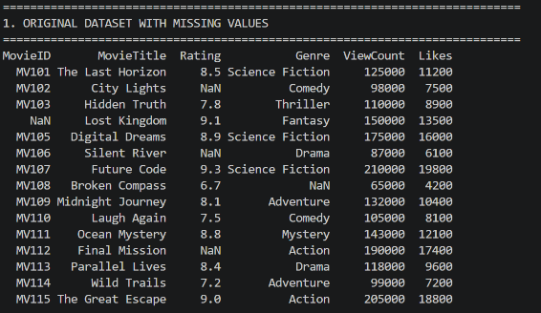  The movie dataset was successfully created in DataFrame format with missing values in the MovieID, Rating, and Genre columns.  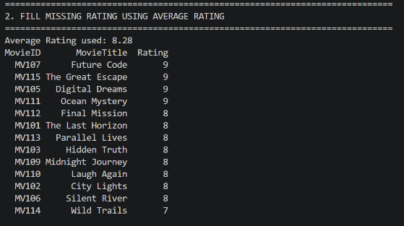  The average rating was calculated successfully and was used to replace all missing Rating values.  Figure 1.1 Original dataset printed after creating the DataFrame (containing missing values).  Figure 1.2 Output showing the calculated average rating.  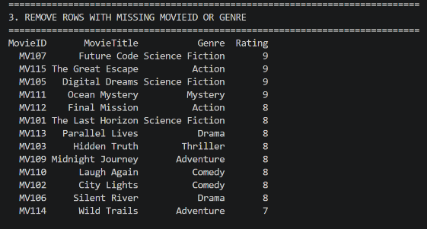  Missing Rating values were replaced with the calculated average rating while preserving all other records.  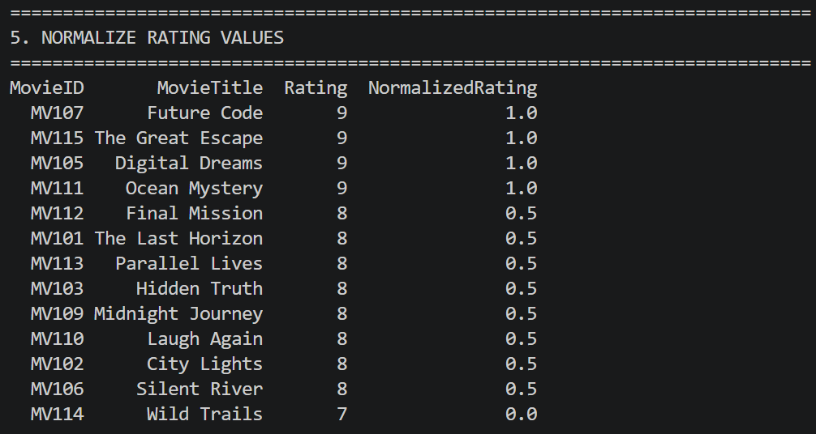  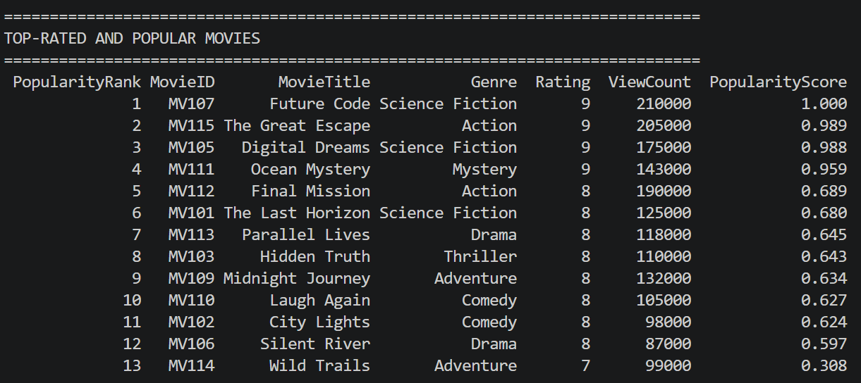  Rating values were converted into integer type and normalized using the Min-Max Normalization technique.  Movies were ranked successfully based on their popularity score, allowing easy identification of top-performing movies.  Figure 1.3 Dataset after fillna() operation.  Figure 1.4 Integer Rating output along with the NormalizedRating column.  Figure 1.5 Sorted movie list showing Popularity Rank.
Conclusions | The Movie Rating Data Preprocessing project was successfully implemented using the Pandas library. The dataset was created with missing values, and the missing Rating values were replaced using the average rating. Records with missing MovieID or Genre were removed to improve data quality. The Rating column was converted into integer type, and the values were normalized using the Min-Max normalization technique. The project also identified top-rated movies, generated genre-wise reports, analysed viewer preferences, recommended movies based on genre and rating, and visualized movie popularity trends. This exercise provided practical knowledge of data preprocessing, data analysis, and dashboard development using Python, Pandas, and Streamlit.
References | - Michael Freeman and Joel Ross, Programming Skills for Data Science: Start Writing Code to Wrangle, Analyze, and Visualize Data with R, Addison-Wesley, 2018  - Python Program (Google Colab link /Githab link)  - Class lecture link

